**STATISTICAL INSIGHT**

|  |  |
| --- | --- |
| **CATEGORY** | **FIRST MOVEMENT BUSINESS DECISION** |
|  |  |
| **COUNT** | 80962 |
| **MIN** | -540 |
| **MAX** | 600 |
| **AVERAGE FOR QTY** | 42.965 |
| **AVERAGE FOR WHNAME** | 1030.9 |
| **MEAN** | 42.965 |
| **MEDIAN** | 100 |
| **MODE FOR QTY** | 100 |
| **MODE FOR WHNAME** | 1009 |
| **MODE FOR STATE** | MAHARASTRA |
| **MODE FOR CITY** | AHMEDABAD |
| **MODE FOR REGION** | NORTH |
| **MODE FOR PRODUCT_CODE** | AO10000035 |
| **MODE FOR TRANSACTION_TYPE** | ALLOT |

|  |  |
| --- | --- |
| **CATEGORY** | **SECOND MOVEMENT BUSINESS DECISION** |
|  |  |
| **STANDARD DEVIATION FOR QTY** | 212.7005029 |
| **RANGE FOR QTY** | 1140 |
| **VARIANCE FOR QTY** | 45241.50394 |
|  |  |
| **CATEGORY** | **THIRD MOVEMENT BUSINESS DECISION** |
|  |  |
| **SKEWNESS** | -0.213993778 |
|  |  |
| **CATEGORY** | **FOURTH MOVEMENT BUSINESS DECISION** |
|  |  |
| **KURTOSIS** | -0.917798458 |

|  |  |
| --- | --- |
| **CATEGORY** | **DATA PREPROCESSING** |
|  |  |
| **NULL VALUES** | NO NULL VALUES ARE PRESENT |
| OUTLIERS | NO OUTLIERS ARE PRESENT |
| DUPLICATES | 11291 |
| MISSING VALUES | NO MISSING VALUES ARE PRESENT |

|  |  |  |
| --- | --- | --- |
| **FEATURE** | **BEFORE EDA** | **AFTER EDA** |
|  |  |  |
| **COLUMNS** | 9 | 9 |
| **ROWS** | 80962 | 64024 |
| **DATE** | 1608 | 1608 |
| **CUSTNAME** | 4183 | 4183 |
| **CITY** | 696 | 696 |
| **REGION** | 4 | 4 |
| **STATE** | 33 | 33 |
| **PRODUCT_CODE** | 70 | 70 |
| **TRANSACTION_TYPE** | 2 | 2 |
| **QTY** | 961 | 961 |
| **WHNAME** | 87 | 87 |

|  |  |  |
| --- | --- | --- |
| **NULL VALUES** | NO NULL VALUES | NO NULL VALUES |
| **OUTLIERS** | NO OUTLIERS | NO OUTLIERS |
| **MISSING VALUES** | NO MISSING VALUES | NO MISSING VALUES |
| **DUPLICATES** | 11291 | NO DUPLICATES |
|  |  |  |
| **MEAN** | 42.965 | 43.0152 |
| **MEDIAN** | 100 | 100 |
| **MODE** | 100 | 100 |
| **SKEWNESS** | -0.21399 | -0.1729 |
| **KURTOSIS** | -0.9177 | -0.8636 |
| **STANDARD DEVIATION** | 212.7005 | 211.016 |
| **RANGE** | 1140 | 1140 |
| **VARIANCE** | 45241.503 | 44528.051 |

**BUSINESS INSIGHT**

**BUSINESS PROBLEM:** No of pallets to be stored in the inventory for shipping for different customers is very volatile leading to understocking and overstocking

**BUSINESS OBJECTIVE**: Minimize the volatility in inventory stock

**BUSINESS SUCCESS** **CRITERIA :** Reduce the volatility by 90%

**ECONOMIC SUSCESS CRITERIA:** Achieve the cost saving of at least $1m

**BEFORE EXPLORATORY DATA ANALYSIS**

|  |  |
| --- | --- |
| **COLUMN** | **BUSINESS MOVEMENT** |
|  |  |
| **FIRST MOVEMENT BUSINESS DECISION** | The mean of the QTY is 42.965, indicating the average number of quantity in the quantity column. |
|  | The median of the QTY is 100, which is the middle most value of the quantity column. |
|  | The mode of the QTY is 100, which is the most frequent number of quantities involved in the transaction. |
|  | The Maximum value of the QTY is 600, which is the highest number of quantity involved in the transaction. |
|  | The minimum value of qty is -540, which is the highest number of quantity involved in the transaction |
|  |  |
| **SECOND MOVEMENT DECISION** | The Variance of the QTY is 45241.5039350354, indicating the degree of spread of values in the column. |
|  | The Standard deviation of the QTY is 212.700502902638, indicates dispersion in the quantity column. |
|  | The Range of the QTY is 1140, is the range between which the number of orders has been placed |
|  |  |
| **THIRD MOVEMENT BUSINESS DECICION** | The Skewness of the QTY is -0.21399, indicating negative skewness. |
|  |  |
| **FOURTH MOVEMENT BUSINESS DECISION** | The Kurtosis of the QTY is -0.9177, indicating platy kurtic distribution. |
|  |  |
| **CUSTNAME** | The mode of the CustName is 11, which is the most frequent code of the customer. |
| **CITY** | The mode of the City is Ahmedabad, indicates Ahmedabad is the most frequently transacted city. |
| **REGION** | The mode of the Region is North, indicates North is the most frequent Region. |
| **STATE** | The mode of the State is Maharastra, which is the most frequently state. |
| **PRODUCT CODE** | The mode of the Product Code is A010000035, which is the most frequent code of product. |
| **TRANSACTION TYPE** | The mode of the Transaction type is Allot, which is the most frequent type of Transaction. |
| **WHNAME** | The mode of the WHName is 1009, which is the most frequent Ware house name. |
|  |  |
|  | **DATA PREPROCESSING** |
|  |  |
| **MISSING VALUES** | No missing values are present |
| **OUTLIERS** | No outliers are present |
| **NULL VALUES** | No null values are present |
| **DUPLICATES** | 11291 duplicates are present |

**AFTER EXPLORATORY DATA ANALYSIS**

|  |  |
| --- | --- |
| **COLUMN** | **BUSINESS MOVEMENT** |
|  |  |
| **FIRST MOVEMENT BUSINESS DECISION** | The mean of the QTY is 43.0152 , indicating the average number of quantity in the quantity column. |
|  | The median of the QTY is 100, which is the middle most value of the quantity column. |
|  | The mode of the QTY is 100, which is the most frequent number of quantities involved in the transaction. |
|  | The Maximum value of the QTY is 600, which is the highest number of quantity involved in the transaction. |
|  | The minimum value of qty is -540, which is the highest number of quantity involved in the transaction |
|  |  |
| **SECOND MOVEMENT DECISION** | The Variance of the QTY is 44528.051 indicating the degree of spread of values in the column. |
|  | The Standard deviation of the QTY is 212.016, indicates dispersion in the quantity column. |
|  | The Range of the QTY is 1140, is the range between which the number of orders has been placed |
|  |  |
| **THIRD MOVEMENT BUSINESS DECICION** | The Skewness of the QTY is -0.1729, indicating negative skewness. |

|  |  |
| --- | --- |
|  |  |
| **FOURTH MOVEMENT BUSINESS DECISION** | The Kurtosis of the QTY is -0.8636, indicating platy kurtic distribution. |
|  |  |
| **CUSTNAME** | The mode of the CustName is 11, which is the most frequent code of the customer. |
| **CITY** | The mode of the City is Ahmedabad, indicates Ahmedabad is the most frequently transacted city. |
| **REGION** | The mode of the Region is North, indicates North is the most frequent Region. |
| **STATE** | The mode of the State is Maharastra, which is the most frequently state. |
| **PRODUCT CODE** | The mode of the Product Code is A010000035, which is the most frequent code of product. |
| **TRANSACTION TYPE** | The mode of the Transaction type is Allot, which is the most frequent type of Transaction. |
| **WHNAME** | The mode of the WHName is 1009, which is the most frequent Ware house name. |
|  |  |
|  | **DATA PREPROCESSING** |
|  |  |
| **MISSING VALUES** | No missing values are present |
| **OUTLIERS** | No outliers are present |
| **NULL VALUES** | No null values are present |
| **DUPLICATES** | No duplicates are present |

**BEFORE EDA INSIGHTS:**

1. 96

**AFTER EDA INSIGHTS:**

1. customer ordered each product atleast 50 unit and max 600 units
2. most ordered product is A010000035 so if we maintain more units of this product would be benefit
3. so, maintaining each product 100 or 120 units would be better in inventory room
4. customer name 11 is the most frequent customer
5. the city ahmedabad is the most frequent city
6. the state maharastra the most frequent state
7. the region north is the most frequent region
8. the product code a010000035 is the most frequent product
9. the most frequent transaction type is allot
10. the warehouse 1009 is the most frequent warehouse
11. the duplicates were also removed
12. there were no missing,null, or outlier values
13. we can further vizualize the data to understand better

hence from this data preprocessing process ,

1. we can find which customer, product, city, region, state, warehouse, transaction type are the most used
2. we can maintain the stock of the product in each warehouse according to the customer
3. we can reduce the volatility of the stock
4. we can achieve a lot of cost saving
5. we can track the data for future purpose
6. we can improve the customer service better
7. we can deliver the product on time without any problem
8. we can improve the inventory system

|  |
| --- |
| 1. We can see that approximately 43 units are sold per order. |
| 1. Mostly Customers buy 100 units per order. |
| 1. Maximum of 600 units is sold per order & max of 540 units has been returned from Customer. |
| 1. Maintaining 100 units of each product in inventory is better |
| 1. Product A010000035 is sold frequently from Warehouse 1009 |

**PYTHON DATA VIZUALIZATION INSIGHTS**

**BOX CHART**

**QTY**

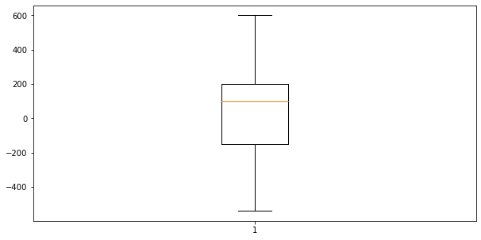

1. THERE ARE NO OUTLIERS ARE PRESENT
2. THE MEDIAN IS ABOVE THE 0(Q2) POINT
3. BOX CHART IS ONLY USED FOR SINGLE VARIABLE OR UNIVARIATE

**WHNAME**

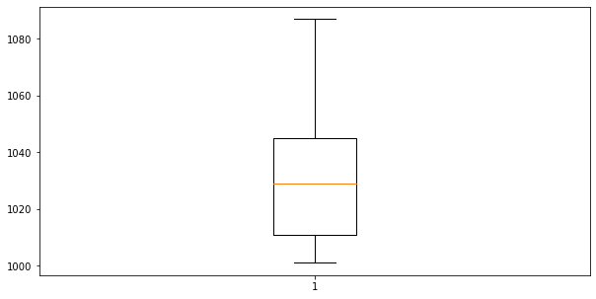

1. THE UPPER LIMIT VALUES ARE MAXIMUM
2. THE LOWER LIMIT VALUES ARE MINIMUM
3. THE MEDIAN IS RIGHT AT THE MIDDLE

**CUSTNAME**

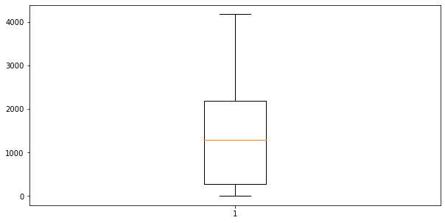

1. THE UPPER LIMIT VALUES ARE MAXIMUM
2. THE LOWER LIMIT VALUES ARE MINIMUM
3. THE MEDIAN IS AT THE MIDDLE POINT
4. IT IS SAME AS THE WHNAME BOX PLOT

**BAR CHART**

**WHNAME & CUSTNAME**

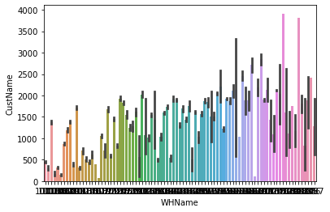

1. THE X VALUE REPRESENT THE WHNAME AND THE Y VALUE REPRESENT THE CUSTNAME
2. SOME OF THE CUSTOMERS ARE FREQUENTLY RECEIVED THE PRODUCTS FROM THE PARTICULAR WAREHOUSE….
3. AND THE SOME THE WAREHOUSE MAINTAINS LOW CUSTOMERS

**REGION AND QTY**

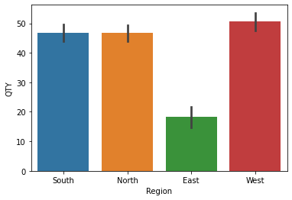

1. THERE ARE FOUR REGIONS (SOUTH ,NORTH, EAST,WEST)
2. THE QTY IN THE WEST IS MOST THAN THE REST OF ALL REGIONS
3. THE QTY IN EAST IS THE LOWEST AMONG THE OTHER REGIONS
4. THE SOUTH AND NORTH REGIONS ARE AMONG THE SAME QTY

**TRANSACTION TYPE AND QTY**

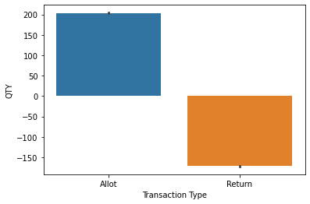

1. THERE ARE TWO TRANSACTION TYPE (ALLOT, RETURN)
2. THE QTY ABOVE THE 0 POINTS ARE ALLOT THAT MEANS THERE ARE MORE PRODUCTS ALLOTED FOR CUSTOMER
3. THE QTY BELOW O POINTS ARE RETURN THAT MEANS THERE ARE NO PRODUCTS FOR CUSTOMERS

**STATE AND CUSTNAME**

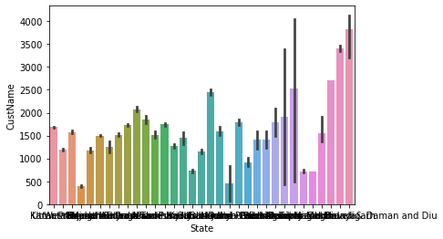

1. THERE ARE SOME STATE WHERE THE CUSTOMERS AND MORE TO BUY THE PRODUCT
2. THERE ARE SOME STATE WHERE THE CUSTOMERS ARE LESS TO VUY THE PRODUCT
3. EACH STATE CARIES FROM THE CUSTOMER TO CUSTOMER
4. FROM THIS DATA WE CANT TELL THE SPECIFIC RESULT

**LINE CHART**

**REGION AND WHNAME**

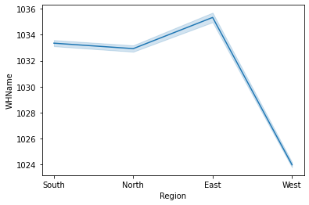

1. THE FIG IS BASED ON THE REGION AND WAREHOUSE
2. THE LINE HAS BEEN RAISED UP AND THEN A DOWNFALL
3. THE SOUTH AND NORTH REGION IS MOSTLY USES THE WAREHOUSE BETWEEN 1032-1034
4. THE EAST REGION USED THE 1036 WAREHOUSE
5. THE WEST REGION USED THE 1024 MAINLY

**TRANSACTION TYPE AND QTY**

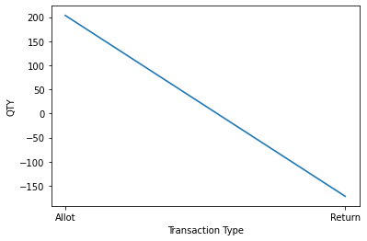

1. IN THIS FIG
2. THE ALLOT TYPE HAVE A QTY ABOVE 0 (POSITIVE)
3. THE RETURN TYPE HAVE A QTY BELOW 0 (NEGATIVE)
4. THIS PRODUCES A STRAIGHT SLANTING LINE FROM 200 TO -150

**REGION AND TRANSACTION TYPE**

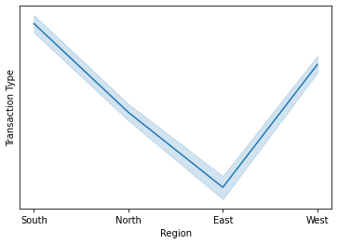

1. THE SOUTH AND NORTH REGION HAVE THE ALLOT TRANSACTION TYPE AND DECRESED TO RETURN TYPE
2. IN EAST REGION THERE ARE MORE RETURN TYPE
3. THE WEST REGION HAVE RAISED FROM RETURN TO ALLOT TYPE

**STATE AND WHNAME**

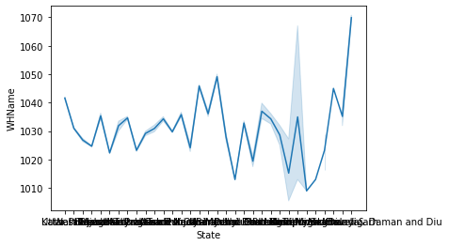

1. THERE IS A DRASTIC CHANGES IN THE LINE CHART FROM UP TO DOWN LIKE MOUNTAINS
2. MOST OF THE STATES USES THE WAREHOUSE ON THE RANGE OF 1010- 1050
3. ONLY SOME OF THE STATES USES 1040-1070 WAREHOUSE

**WHNAME AND TRANSACTION TYPE**

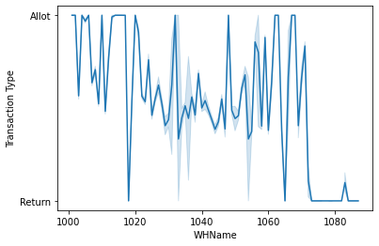

1. THIS CHART HAVE A MUTIPLE CHANGES IN THE LINE CHART LIKE HEART BEAT MONITOR
2. LIKE AS WE SAW MOST OF THE WAREHOUSES HAVE ALLOT TYPE OF TRANSACTION
3. ONLY SOME OF THE WAREHOUSE HAVE RETURN TYPE TRANSACTION
4. THE 1020,1065,1070-1085 HAVE THE RETURN TYPE,OTHERS HAVE ALLOT TYPE

**REGION AND QTY**

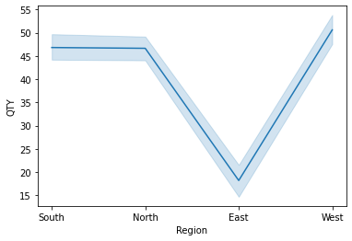

1. THE REGION IN SOUTH AND NORTH HAVE THE SAME QTY OF RANGE 47
2. THE WEST REGION HAVE MORE THE 50 QTY
3. THE EAST REGION HAVE LOW QTY OF 15 IN THER WAREHOUSE

**HISTOGRAM**

**QTY**

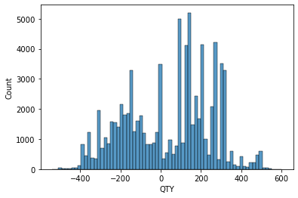

1. THIS IS UNIVARIATE ANALYSIS THAT HAVE ONLY ONE WARIABLE
2. THE MOST QTY OF THE PRODUCT RANGES BETWEEN -400 TO 400
3. THE MOST NUMBER OF QTY IS THAT STOCKS ARE 0 TO 250 QTY IN WAREHOUSE
4. THE COUNT OF THE QTY RANGES MORE BLOEW 2000

**REGION**

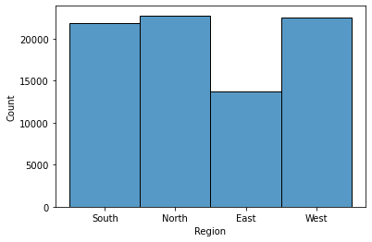

1. THE EAST REGION IS THE LOWEST
2. THE WEST AND NORTH HAVE THE SAME COUNT
3. THE SOUTH HAVE A SLIGHT COUNT LESS THEN NORTH AND WEST

**TRANSACTION TYPE**

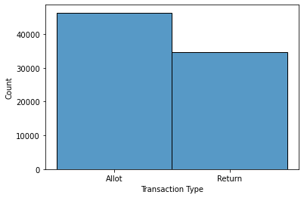

1. THE ALLOT TYPE HAVE MORE COUNT THAN RETURN TYPE

**CUSTNAME**

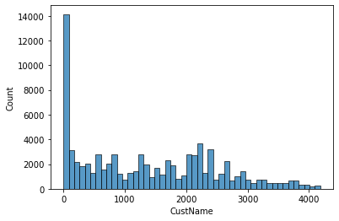

1. THERE ARE MORE THE 4000 CUSTOMERS
2. THE MOST OF THE CUSTOMERS THE BOUGHT THE PRODUCT ARE BELOW 1000

**WHNAME**

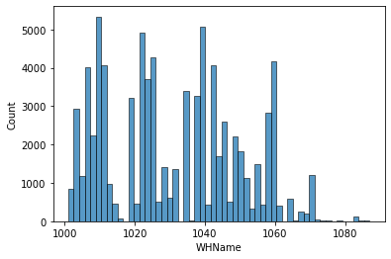

1. THE WAREHOUSE OF 1020-1040 ARE THE HIGHEST USE WAREHOUSE
2. THE WAREHOUSE FROM 1000-1020 ARE SAME AMOUNT AS THE WAREHOUSE BETWEEN 1020-1040
3. THE WAREHOUSE 1060-1080 ARE THE LOWEST USE
4. THE WAREHOUSE BETWEEN 1040-1060 ARE THE MODERATE USE

**SCATTER PLOT**

**QTY AND REGION**

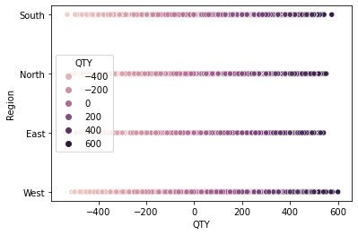

1. EACH REGION HAVE LESS QTY OF PRODUCTS BUT THE WEST IS THE MOST HIGHEST NUMBER OF QTY , NORTH AND SOUTH ARE SAME
2. EAST IS THE LOWEST NO OF QTY

**CUSTNAME AND QTY**

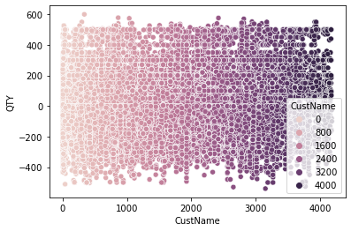

1. THE CUSTOMER ABOVE 2500 HAVE THE HIGHEST ORDER OF QTY OF PRODUCT
2. THE CUSTOMER BELOW 2000 HAVE THE LOWEST QTY OF PRODUCT

**QTY AND STATE**

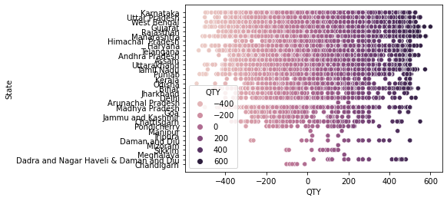

1. THE GUJARAT , TAMILNADU, RAJASTAN,UTTAR PRADESH,MAHARASTRA,KARNATAKA,TELANGANA,WEST BENGAL,ANDHRA PRADESH

HAVE THE HIGHEST NUMBER OF QTY ABOVE 600

1. THE DAMAN AND DIU , CHANDIGARH, SIKKIM, MIZORAM, GOA, JAMMU, PONDICHERRY, MEGHALAYA,MANIPUR HAVE THE LOWEST QTY OF THE STATE

**QTY AND WHNAME**

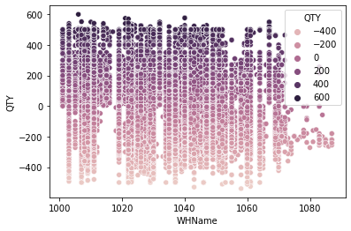

1. THE WAREHOUSE ABOVE 1020-1040 HAVE THE HIGHEST ORDER OF QTY OF PRODUCT
2. THE WAREHOUSE BELOW 1060-1080 HAVE THE LOWEST QTY OF PRODUCT
3. MOST OF THE WAREHOUSE HAVE INSTOCK QTY OF MINIMUM 100
4. MANY OF THE WAREHOUSE HAVE ALSO NEGATIVE QTY OF STOCK

**AUTO EDA (Using Cleaned Data)**

**D-Tale :**

**Insights :**

* D-Tale is a Python library that provides an interactive web-based interface for data analysis.
* It allows users to visualize, explore, and analyze data frames in an interactive manner.
* It can be particularly useful for data analysis in Python-based projects. On the top corner it has the details regarding no of records present in our dataset along with the no of variables present in our data and it adds one more index column to our data
* In our data we have 64024 records with 9 variables but it adds one index column and showing 10 variables with the 64024 records

**# SWEETVIZ :**

**Insights :**

* Auto EDA tools, such as Sweetviz, automate the process of exploring and visualizing datasets.
* They generate various statistical analyses and visualizations to help users understand the patterns, distributions, and relationships within their data.

**Date variable:**

* We have almost 3% of distinct values and the most repeatedly occurred ordered date with 114 times on 2023-02-13.

**Customer name variable:**

* We have 7% of distinct values in our data for this column
* Skewness is positive the data is pushed towards right with a long right tail
* The distribution is platykurtic with wide peak and a thin tail

**City variable:**

* We have total 736 different cities in our city variable which is equal 1% of our data
* Ahmedabad is the most repeatedly ordered city with 4390 orders which is equal to 7% of our total data
* Bangalore stood in the second place with 4182 orders followed by different cities

**Region variable:**

* We have only 4 distinct values in this column which is less than 1%
* North stood in the first place in orders placing with nearly 28% and little less in West
* We got less orders from East region with almost 15%

**State variable:**

* We have 33 distinct states in our data which is less than 1%
* We got more orders from Maharashtra around 16%-17%followed by Utter Pradesh, Karnataka and Gujarat

**Product Code variable:**

* We have 70 distinct product codes in our data which is less than 1%
* We got more orders for the product code A010000035 with nearly 46%

**Transaction Type variable:**

* We have only 2 distinct values with allot and returns
* We have almost 57% for the orders allotted and nearly 43% of orders are

Returned

**QTY variable:**

* We have 961 distinct values in our qty column which is 2% of our data
* Most repeatedly ordered quantity is 100
* Maximum ordered quantity is 600 and the max return value is 540
* Average quantity of orders we got is 43
* The skewness is negative and the data points pushed towards left and it is left tailed
* The more orders we got for 150-250 quantity
* It has negative kurtosis with platykurtic distribution and wide peak with thin tail

**WHName variable:**

* It consists of 87 distinct values which is less than 1% of our data
* We got more orders to the warehouse name 1009
* The skewness is positive for this column and it has a long right tail
* Kurtosis is negative and the distribution is platykurtic

**# AUTOVIZ :**

**Insights :**

* Visualize the availability of Quantity of pallets in ware houses.
* Identify periods where popular items are out of stock or have limited availability.
* Use visualizations to understand stock levels, reorder points, and supply chain dynamics.

**Scatter Plot (QTY vs Cust-Name, QTY vs WH -Name, WH-Name vs Cust-Name)**

* Direction: They are not correlated with each other
* Strength is weak for these variables
* There is no linearity present in between these variables

**Distribution Plot (WH-Name, QTY, Cust-Name)**

**QTY variable:**

* + It displays the distribution of the data
  + The distribution of skewness of QTY is Negative Skewness
  + The Kurtosis of QTY is Platykurtic
  + The peak point of quantity is nearly at 150

**Customer name variable:**

* Skewness is positive the data is pushed towards right with a long right tail
* The distribution is platykurtic with wide peak and a thin tail

**WH-Name variable:**

* We got 2 gap points in our distribution plot that indicates that it doesn’t have sales activity on those warehouses
* Warehouse no 1009 has got the peak orders
* Skewness is positive the data is pushed towards right with a long right tail
* The distribution is platykurtic with wide peak and a thin tail

**Box Plot (WH-Name, QTY, Cust-Name)**

**QTY variable:**

* The points which are outside the whisker considered as outliers
* We don't have outliers in our data
* Median value push towards the right side
* The data is not symmetrical
* It is left skewed
* Min value is -540
* Max value is 600

**Cust-Name, WH-Name variable:**

* The whisker line is more at the right end it indicates that there are more extreme high values in our data
* Based on that we can say that the distribution is positively skewed

**Bar graph (Transaction type, Region, State, Product Code)**

**Transaction type variable:**

* We have almost 57% for the orders allotted and nearly 43% of orders are

Returned

**Region variable:**

* North stood in the first place in orders placing with nearly 28% and little less in West
* We got less orders from East region with almost 15%

**State variable:**

* We got more orders from Maharashtra around 16%-17%followed by Utter Pradesh, Karnataka and Gujarat

**Product Code variable:**

* We got more orders for the product code A010000035 with nearly 46%

**POWERBI INSIGHTS**

**SUM OF CUSTNAME BY REGION**

**TREE MAP**

* EAST REGION IS THE LOWEST CUSTOMER
* NORTH REGION HAS THE HIGHEST CUSTOMER
* WE CAN IMPROVE THE CUSTOMER IN THE EAST REGION

**SUM OF WHNAME BY REGION**

**BAR CHART**

* EAST REGION HAS THE LOWEST WAREHOUSE
* NORTH REGION HAS THE HIGHEST WAREHOUSE
* WE CAN IMPROVE THE WAREHOUSE NUMBER IN EAST REGION

**SUM OF CUSTNAME BY CITY & YEAR**

**AREA CHART**

* IN BANGALORE 2022 IS THE HIGHEST CUSTOMER, 2019 IS THE LOWEST CUSTOMER
* IN PUNE 2022 IS THE HIGHEST CUSTOMER, 2019 IS THE LOWEST CUSTOMER
* IN GURGAON 2022 IS THE HIGHEST CUSTOMER, 2019 IS THE LOWEST CUSTOMER
* IN HYDERABAD 2022 IS THE HIGHEST CUSTOMER, 2019 IS THE LOWEST CUSTOMER
* IN BHIWANDE 2022 IS THE HIGHEST CUSTOMER, 2019 IS THE LOWEST CUSTOMER
* THESE ARE THE TOP FIVE CITIES WITH THE HIGHEST AND LOWEST CUSTOMER IN THE CITY ON EACH YEAR
* WE CAN IMPROVE THE CUSTOMER IN THE UPCOMING YEAR LIKE 2022

**SUM OF WHNAME BY STATE**

**DONUT CHART**

* MAHARSTRA WITH THE WAREHOUSE OF 11M AND 32.7%
* KARNATAKA WITH THE WAREHOUSE OF 7M AND 20.7%
* GUJARAT WITH THE WAREHOUSE OF 6M AND 18.9%
* WEST BENGAL WITH THE WAREHOUSE OF 5M AND 15%
* TAMILNADU WITH THE WAREHOUSE OF 4M AND 11.7%
* THESE ARE THE TOP 5 STATES WITH THE WAREHOUSE WHERE TAMILNADU IS THE LOWEST AND MAHARASTRA WITH THE HIGHEST, WE CAN IMPROVE THE WAREHOUSE IN THE TAMILNADU STATE

**SUM OF QTR & SUM OF WHNAME BY MONTH NAME**

**LINE AND CLUSTERED COLUMN CHART**

* JAN, FEB, MAR, SEP, AUG HAS THE HIGHEST MONTH WHERE THERE WERE MORE QTY IN WAREHOUSE
* AND THE WAREHOUSE GETS DECRESES IN FEB, MAR, SEP AND THEN GETS INCRESED IN JUNE MONTH

**SUM OF WHNAME & SUM OF QTR BY TRANSACTION TYPE**

**LINE CHART**

* THE WAREHOUSE AND QTY HAVE MORE ALLOT TYPE AND DECREASED TO RETURN TYPE
* THAT MEANS THE QTY IN THE WAREHOUSE HAVE MORE ALLOT THAN RETURN

**SUM OF QTY BY REGION**

**PIE CHART**

* THE EAST REGION IS THE LOWEST QTY OF 243K OF 9.6%
* THE WEST REGION IS THE HIGHEST QTY OF 918.6K OF 33.3%
* THEN WE CAN INCREASE THE QTY IN EAST REGION

**SUM OF QTY BY YEAR**

**FUNNEL CHART**

* 2023 IS THE LOWEST QTY OF ALL OF 0.09M (6.7%)  
  2019 IS THE HIGHEST QTY OF ALL OF 1.28M (100%)
* THE UPCOMING YEAR CAN BE INCRESE THE QTY IN EACH WAREHOUSE

**SUM OF QTY & SUM ON CUSTNAME BY STATE**

**SCATTER CHART**

* TRIPURA,CHATTISGARH,PONDICHERY IS THE LOWEST QTY AND LOWEST CUSTNAME BY THE STATE
* THE MAHARASTRA,KARNATAKA,GUJARAT,WESTBENGAL,TAMIILNADU IS THE HIGHEST CUSTNAME AND QTY BY THEN STATE
* WE CAN IMPROVE THE QTY IN THE LOWEST REGION , AND INCREASE THE CUSTOMERS

**SUM OF QTY BY CITY,YEAR**

**RIBBON CHART**

THE AHMEDABAD AND BANGALORE HAVE THE HIGHEST QTY IN EACH YEAR

AND THE COMES THE PUNE,BHIWANDI,VADODARA, WITH THE UPCOMING QTY IN EACH YEAR

THE PATNA,RANCHI,FAIZABAD,HYDERABAD HAVE THE LOWEST QTY AND THE QTY ARE IN RETURN TYPE IN THOSE CITY EACH YEAR ,, WE CAN IMPROVE THE QTY IN THOSE CITIES

**SUM OF QTY BY TRANSACTION TYPE BY MONTH NAME**

**STACKED BAR CHART**

* IN RETURN TYPE , JULY IS THE HIGHEST RETURN AND OCTOBER IS THE LOWEST RETURN
* IN ALLOT TYPE , FEBRUARY IS THE HIGHEST ALLOT AND OCTOBER IS THE LOWEST ALLOT
* FROM THIS OCTOBER IS THE MONTH WITH THE LOWEST QTY ALLOT AND RETURN OF PRODUCT

**COUNT OF QTY BY REGION & YEAR**

**STACKED COLUMN CHART**

* IN 2019, WEST IS THE HIGHEST REGION OF QTY, EAST IS THE LOWEST REGION OF QTY
* IN 2020, NORTH IS THE HIGHEST REGION OF QTY, EAST IS THE LOWEST REGION OF QTY
* IN 2021, SOUTH IS THE HIGHEST REGION OF QTY, NORTH IS THE LOWEST REGION OF QTY
* IN 2022, EAST IS THE HIGHEST REGION OF QTY, WEST IS THE LOWEST REGION OF QTY
* IN 2023, EAST IS THE HIGHEST REGION OF QTY, NORTH IS THE LOWEST REGION OF QTY
* USING THIS CHART WE CAN IMPROVE THE REGION WHERE THE QTY IS LOWEST EACH YEAR

**COUNT OF CUSTNAME BY REGION & DAY**

**STACKED AREA CHART**

* IN NORTH REGION WEDNESDAY IS THE HIGHEST CUSTOMER, SUNDAY IS THE LOWEST CUSTOMER
* IN WEST REGION THURSDAY IS THE HIGHEST CUSTOMER, SUNDAY IS THE LOWEST CUSTOMER
* IN EAST REGION TUESDAY IS THE HIGHEST CUSTOMER, SUNDAY IS THE LOWEST CUSTOMER
* IN SOUTH REGION FRIDAY IS THE HIGHEST CUSTOMER, SUNDAY IS THE LOWEST CUSTOMER
* USING THIS CHART WE CAN IMPROVE THE SUNDAY CUSTOMER RATE IN THE RESPECTED REGION

**SUM OF QTY BY REGION & TRANSACTION TYPE**

**MATRIX**

* IN WEST REGION ALLOT INCRESES, RETURN INCREASES, TOTAL INCREASES
* IN EAST RERGION ALLOT DECREASES, RETURN DECREASES, TOTAL DECREASES
* USING THIS CHART WE CAN IMPROVE THE EAST REGION QTY AND TRANSACTION TYPE , AND REDUCE THE RETURN OF QTY IN WEST REGION

**SUM OF QTY, MIN OF QTY, MAX OF QTY, AVG OF QTY**

**GAUGE CHART**

* -540 IS THE MIN OF QTY
* 600 IS THE HIGHEST OF QTY
* 43.02 IS THE AVG OF QTY
* 2.75M IS THE SUM OF QTY